**Story Description:**

As UW I want the **Agent for Service** field should be changed from Foley & Lardner to Lloyd’s America, Inc

**Business Objectives - Why**

All CA state policies should be defaulted to Lloyd’s America, Inc

**Business Requirements - What**

It is required to change and appear by default to all policies created for CA.

**Functional Requirements – How**

The new quotes should be defaulted to Lloyd’s America and the user should proceed to bound and issue the policy.

**In Scope:**

It applies to Admitted and Surplus CA state policies.

This should be proved when you create a quote (copy a quote for a previously created one)

This should be also tested using a brand-new quote created from Insight.

**Out of Scope:**

Policies created before 6/01/2022 will not be honored.

Non-CA states are out of scope.

**Acceptance Criteria**

It applies to Admitted and Surplus CA state policies.

This should be proved when you create a quote (copy a quote for a previously created one)

This should be also tested using a brand-new quote created from Insight.

**Current State**

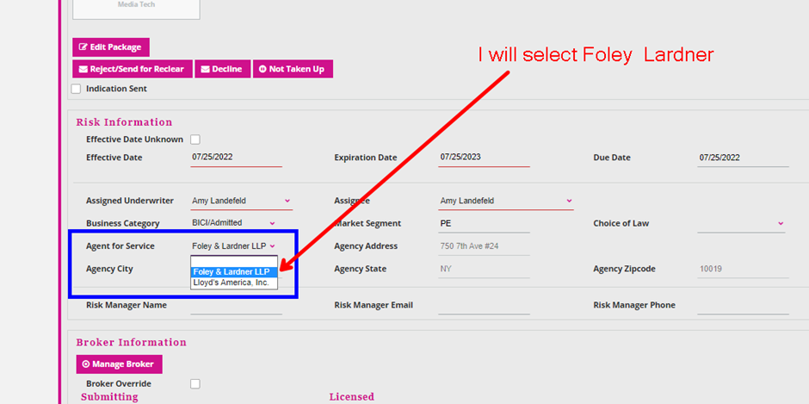

**Future State**

Should be defaulted to Lloyds

